Bio

**How it works**

1. An investor buys Bitcoins to buy Studex coins.Studex then buys the best genetics of studgame wildlife from the top breeders in South Africa
2. The animals bought through the Studex coin are given the best medical care with existing breeding animals that are selected for the Studex coin.
3. Follow the prices of the Studex coin on <https://coinmarketcap.com/in> and the mobile app or within the virtual reality app and decide to sell your animals at any time. You can then re-invest or withdraw your money to any international bank account.
4. You can watch drone videos of the animals in cinematic, buy and sell your Studex coins all within the virtual reality app on Oculus market

**Advantages of Studex**

* First crypto currency backed by rare endangered studgame wildlife
* First privatized responsible animal conservation investment platform
* Protect animals from hunting, poaching, disease and predators
* Largest conservation breeding association with highest pedigree of animals
* 4k & 6k drone content of investors animals daily to mobile app
* International growth to the south African stud game breeding community
* Studex creates international liquidity
* The first cryptocurrency
* Track all transactions within the blockchain
* Cryptocurrency mining in animal reproduction

**Technology**

**Block chain**

## What is a 'Cryptocurrency'

## Studex

* First crypto currency backed by rare endangered studgame wildlife
* First crypto currency backed by rare endangered studgame wildlife
* BREAKING DOWN 'Initial Coin Offering (ICO)'
* When a [cryptocurrency](https://www.investopedia.com/terms/c/cryptocurrency.asp) startup firm wants to raise money through an Initial Coin Offering (ICO), it usually creates a plan on a whitepaper which states what the project is about, what need(s) the project will fulfill upon completion, how much money is needed to undertake the venture, how much of the virtual tokens the pioneers of the project will keep for themselves, what type of money is accepted, and how long the ICO campaign will run for. During the ICO campaign, enthusiasts and supporters of the firm’s initiative buy some of the distributed cryptocoins with [fiat](https://www.investopedia.com/terms/f/fiatmoney.asp) or virtual currency. These coins are referred to as tokens and are similar to shares of a company sold to investors in an [Initial Public Offering](https://www.investopedia.com/terms/i/ipo.asp) (IPO) transaction. If the money raised does not meet the minimum funds required by the firm, the money is returned to the backers and the ICO is deemed to be unsuccessful. If the funds requirements are met within the specified timeframe, the money raised is used to either initiate the new scheme or to complete it.

Early investors in the operation are usually motivated to buy the cryptocoins in the hope that the plan becomes successful after it launches which could translate to a higher cryptocoin value than what they purchased it for before the project was initiated. An example of a successful ICO project that was profitable to early investors is the [smart contracts](https://www.investopedia.com/news/understanding-smart-contracts/)platform called [Ethereum](https://www.investopedia.com/terms/e/ethereum.asp) which has Ethers as its coin tokens. In 2014, the Ethereum project was announced and its ICO raised $18 million in Bitcoins or $0.40 per Ether. The project went live in 2015 and in 2016 had an ether value that went up as high as $14 with a [market capitalization](https://www.investopedia.com/terms/m/marketcapitalization.asp) of over $1 billion.

Studex coin is the first crypto currency for animal conservation. The ICO will start at $500 million USD and later list on the Bitrex, Gdax, Gemini, Luno and Binance exchanges

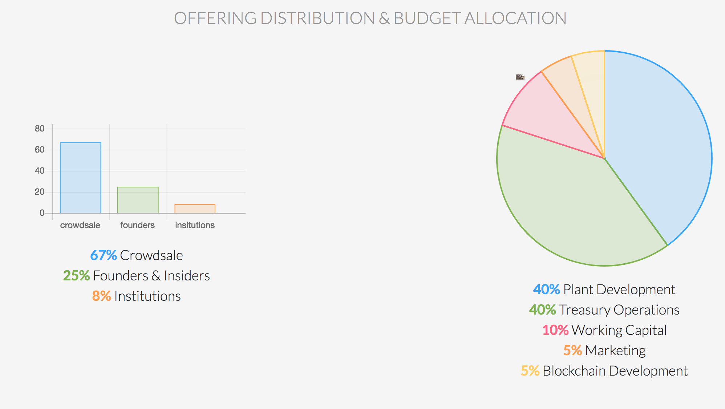

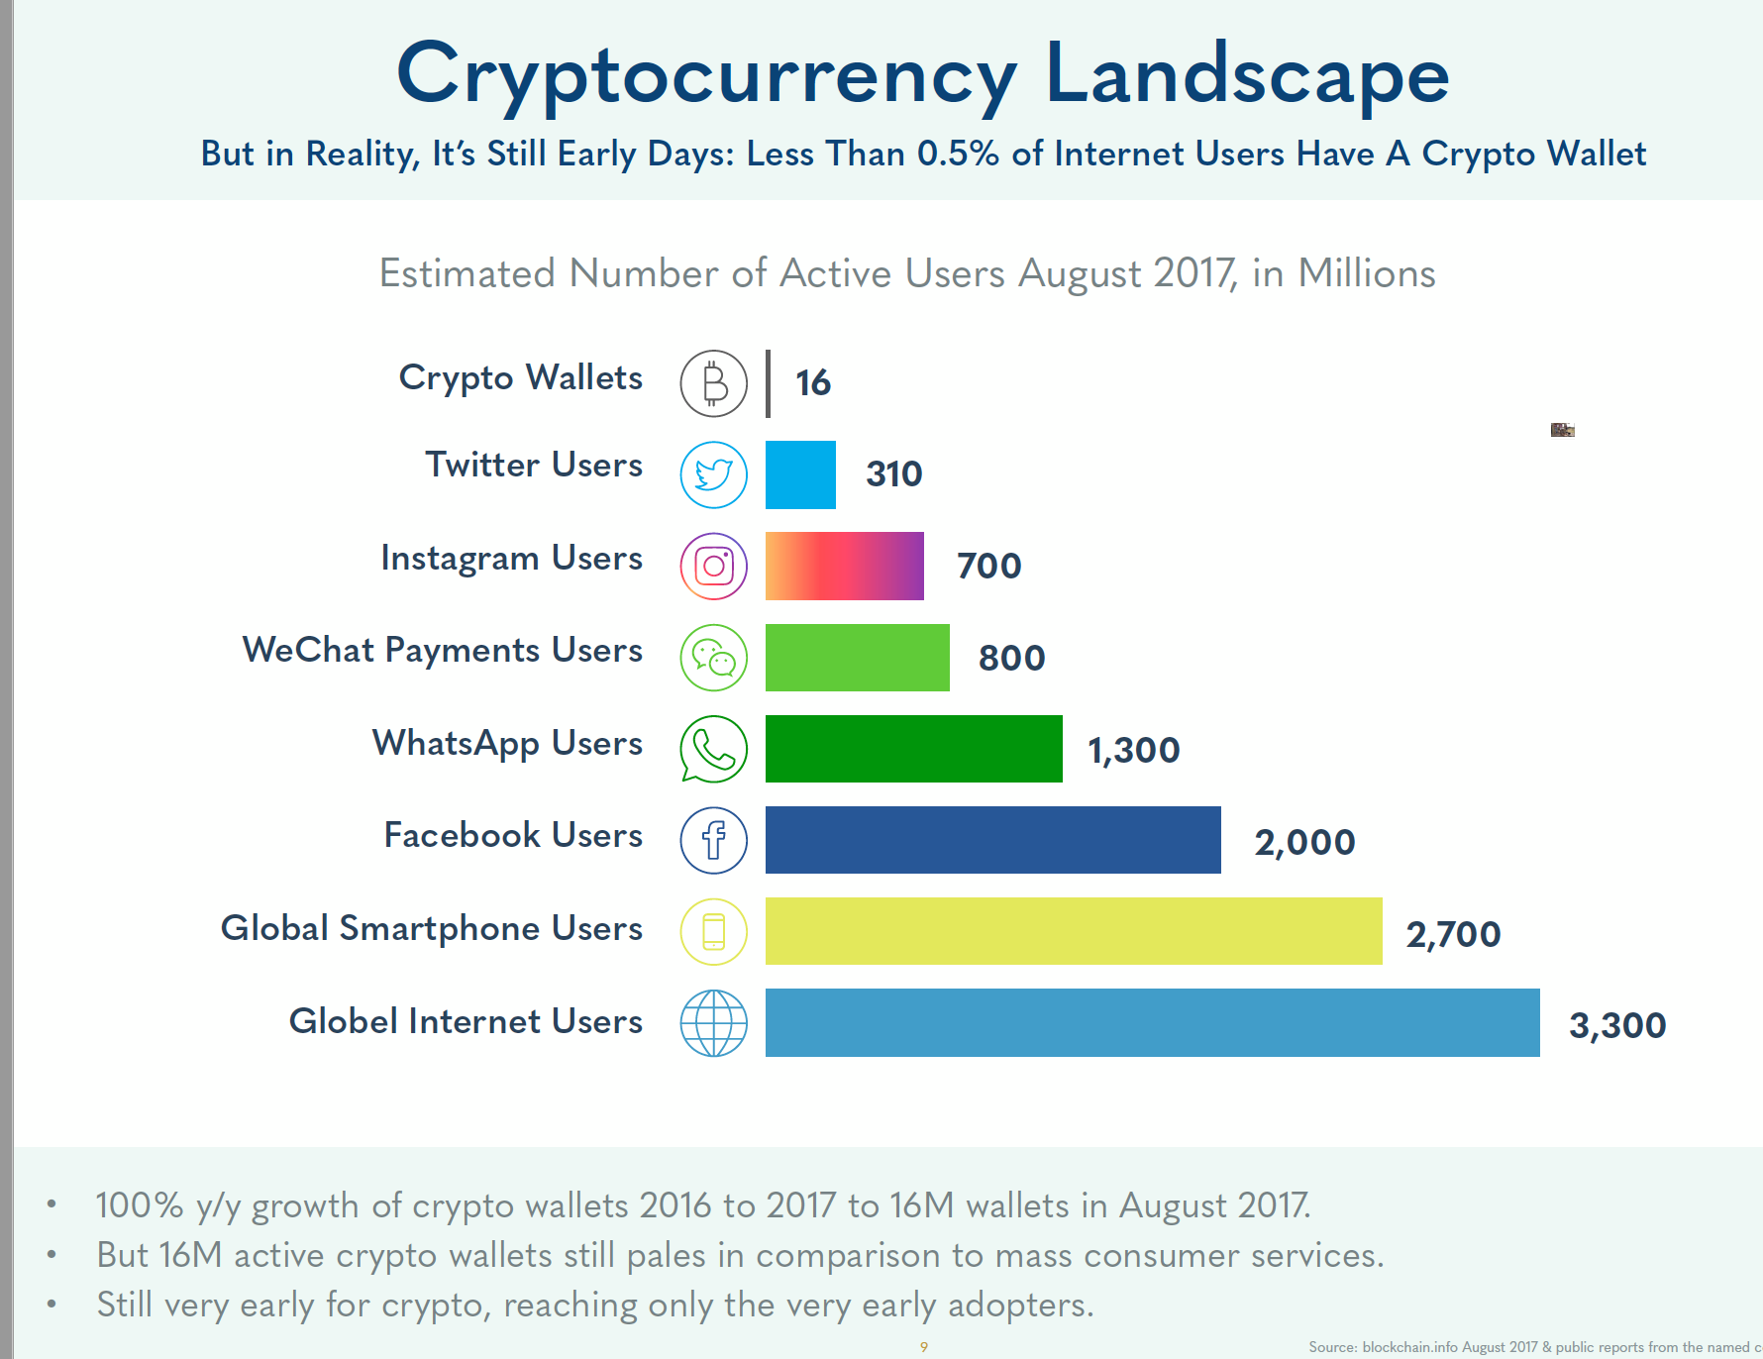  
Read more: [Initial Coin Offering (ICO) Definition | Investopedia](https://www.investopedia.com/terms/i/initial-coin-offering-ico.asp#ixzz546qqyY8G) <https://www.investopedia.com/terms/i/initial-coin-offering-ico.asp#ixzz546qqyY8G>   
Follow us: [Investopedia on Facebook](https://ec.tynt.com/b/rf?id=arwjQmCEqr4l6Cadbi-bnq&u=Investopedia)

## /Users/tumeloramaphosa/Desktop/Screen Shot 2018-01-13 at 15.08.33.png

A cryptocurrency is a digital or virtual currency that uses cryptography for security. A cryptocurrency is difficult to counterfeit because of this security feature. A defining feature of a cryptocurrency, and arguably its most endearing allure, is its organic nature; it is not issued by any central authority, rendering it theoretically immune to government interference or manipulation.

The first cryptocurrency to capture the public imagination was [Bitcoin](https://www.investopedia.com/terms/b/bitcoin.asp), which was launched in 2009 by an individual or group known under the pseudonym Satoshi Nakamoto. As of September 2015, there were over 14.6 million bitcoins in circulation with a total market value of $3.4 billion. Bitcoin's success has spawned a number of competing cryptocurrencies, such as [Litecoin](https://www.investopedia.com/terms/l/litecoin.asp), Namecoin and PPCoin.

